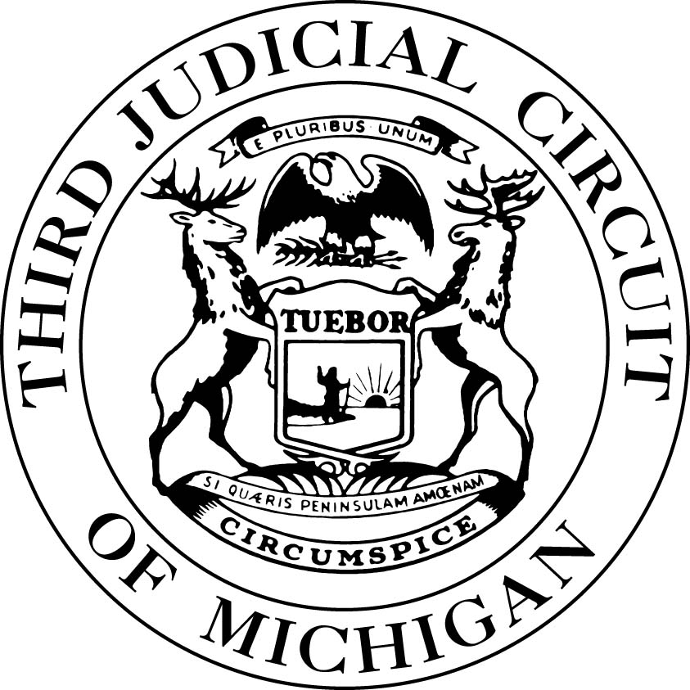
The Wayne County Friend of the Court
Outreach Initiatives

Walk-In Friend of the Court Assistance
Receive information and ask child support professionals questions
regarding your Friend of the Court issues at the following locations:

UAW Region 1A Local 174  Chuck Browning, Regional Director  15140 Livernois, Detroit, MI 48238  (313) 864-7878  Held Every 1st Friday of the Month  9:00 a.m. to 3:00 p.m. | ACCESS: Arab Community Center for Economic & Social Services  6450 Maple Street, Dearborn, MI 48126  (313) 216-2200  Held Every 2nd Friday of the Month  9:00 a.m. to 3:00 p.m.
STARFISH Family Services  26429 Michigan Ave, Inkster, MI 48141  (734) 728-3400  Held Every 1st Tuesday of the Month  9:00 a.m. to 3:00 p.m. | The Resource Network  11816 Jos Campau, Hamtramck, MI 48212  (313) 365-3700  Held Every 3rd Tuesday of the Month  10:00 a.m. to 3:00 p.m.
La Sed: Latin Americans for Social & Economic Development  4138 Vernor Hwy, Detroit, MI 48209  (313) 554-2025  Held Every 2nd Friday of the Month  10:00 a.m. – 4:00 p.m.  English & Spanish Speaking | Focus: HOPE  1200 Oakman Boulevard, Detroit, MI 48238  (313) 494-4300  Held Every 4th Wednesday of the Month  9:00 a.m. to 3:00 p.m.
Wayne County Child Support Help Program
Detroit Public Library
5201 Woodward Avenue, Detroit, MI 48202
(844) 785-7593
Saturday, April 6th and October 12th, 2019
1:00 p.m. – 4:00 p.m.

Any updates to the schedule or location of these events will be posted at www.3rdcc.org
or parties may contact the Friend of the Court Call Center at 1(844)785‑7593.

The Wayne County Friend of the Court
Legal Partner Programs
The William Booth Legal Aid Clinic
Coleman A. Young Municipal Center
Two Woodward Avenue, 7th floor, Training Room 784, Detroit, Michigan 48226

Default Judgment of Divorce Clinic
Held Every 1st Thursday of the Month
Doors open at 10:00 a.m. Parties must arrive by 11:30 a.m. Clinic starts at 12:00 p.m.

Attorneys from the Clinic available to help qualifying, low income, self-represented parties prepare all necessary court documents for Default Judgment of Divorce in Wayne County.

Parties must bring valid photo identification, proof of income, case labels, and all documents related to the case, including the Complaint for Divorce, Friend of the Court Final Recommendation (DM only),
and Fee Waiver (if applicable).

Legal Aid Clinic
Held Every Thursday
(except the first Thursday of the month)
Doors open at 9:30 a.m. Parties must arrive by 11:30 a.m. Clinic starts at 12:00 p.m.

Free help with divorce and Friend of the Court issues. Attorneys from the Clinic available to help qualifying, low income, self-represented parties prepare Complaints, Motions, and Judgments.

Parties must bring valid photo identification, proof of income, and all documents related to the case.

Detroit Legal Services Clinic
Penobscot Building – SMART Detroit 13th Floor
645 Griswold, Detroit, MI 48226
(313) 961-6120 ext. 210
Jul. 24, Aug. 28, Sep. 25, Oct. 23, Nov. 27, Dec. 18, 2018
12:00 p.m. to 3:00 p.m.
Local attorneys and support staff available to provide information and legal advice.

Michigan Legal Self-Help Centers
www.michiganlegalhelp.org

Wayne County  Penobscot Building – Room 1145  11th Floor  645 Griswold, Detroit, MI 48226  Monday through Thursday  9:00 a.m. to 3:00 p.m. | Southwest Detroit  Family Alliance for Change (Spanish/English)  3627 W. Vernor, Detroit, MI 48216  Mondays and Wednesdays  9:00 a.m. to 3:00 p.m.
Self-Help Center staff are available to help you navigate this website which provides forms, instructions, and information you may use to assist you with your legal issues. This is a free resource for area residents who need to represent themselves in simple civil legal matters.
The staff cannot provide legal advice.

